|  |  |  |  |  |  |
| --- | --- | --- | --- | --- | --- |
| Date | 1-Dec-22 | | | Tester Name | Janette Paus |
| Environment | Select Environment | | | Login used |  |
| Operating System | Windows | Version: 21H2 | Update Number: | | |
| Software Used | Select Software | Version: 170.0.1418.56 | Update Number: | | |
| Select Software | Version: | Update Number: | | |
| Application Release version | R22.4.1 | | | | |
| Test Case Title | E20.03 | | | | |
| Test Type | Regression | | | | |
| Test Scenario | Reverse Deposit after Valuation | | | | |
| Expected Results | The reversal should show under Investment/Account Activity with the units deposited and removed. The number of units should equal the amount that was showing prior to the deposit being added. | | | | |
| Pass/Fail | Pass | | | JIRA# |  |

E20.03 – Reverse Deposit after Valuation

Step 1 – Process Deposit

Search for any PEPP member (active or deferred with funds still with PEPP

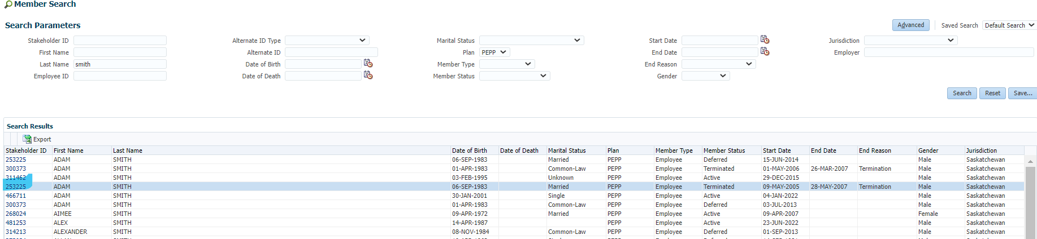

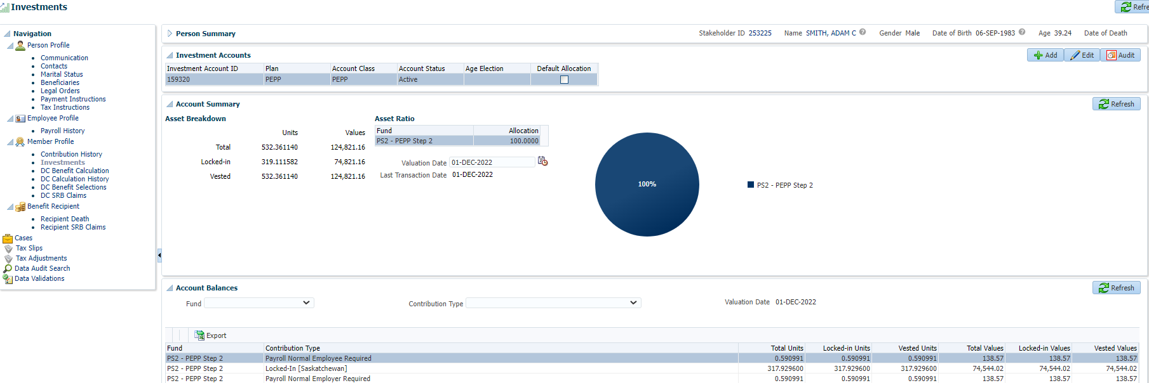

Add remittance and click Save

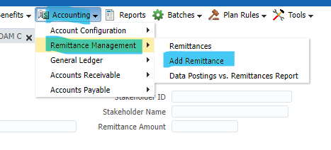

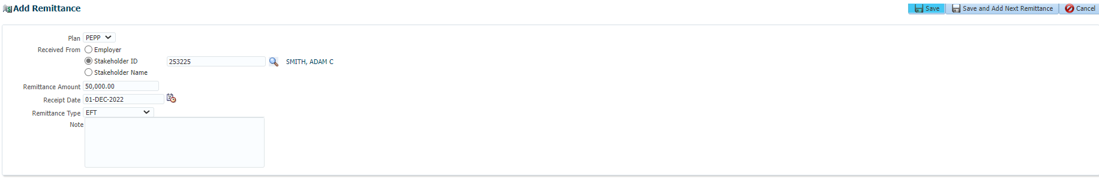

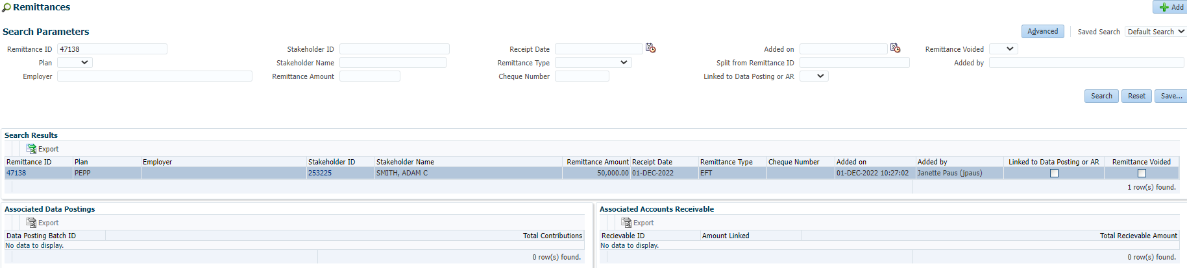

Deposit the funds under the members contribution history

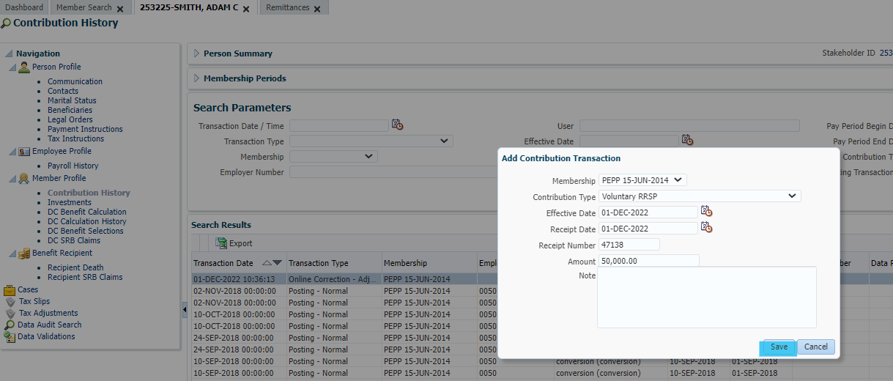

Wait for overnight valuation inn order for reversal to be completed the next day.

NOTE: Reversal itself is a 2-day process.

Step 2 – Next day

Under Member Profile, Contribution History, the Delete button is greyed out

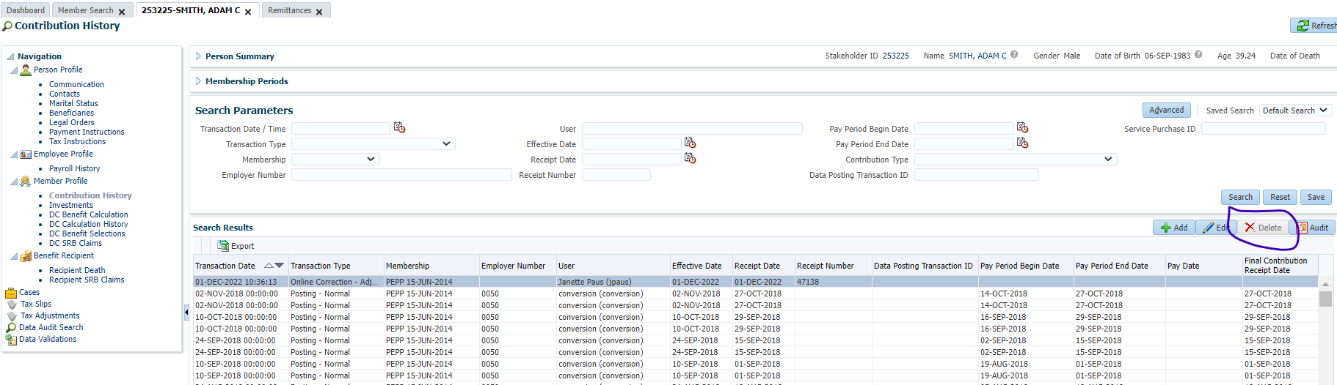

In Member Profile 🡪 Investments 🡪 Account Activity, highlight the Transfer In record and click Reverse, then yes to the pop-up.

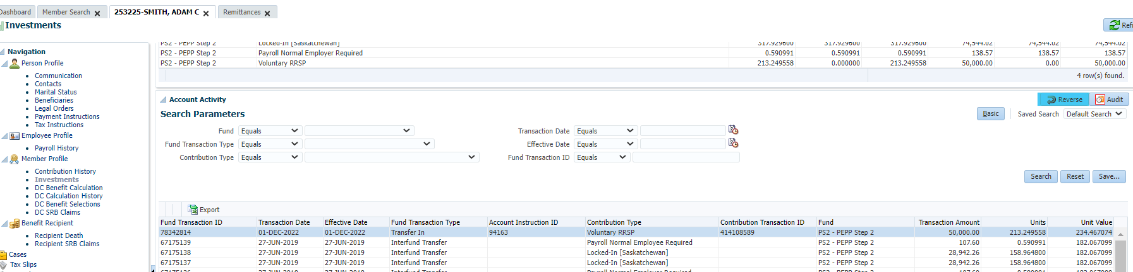

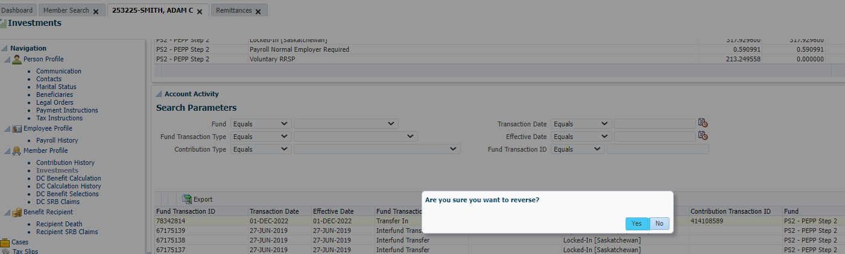

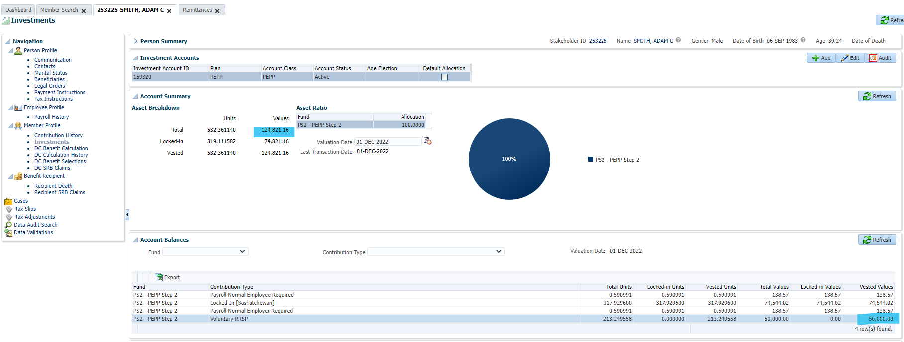

Check tomorrow, units removed after reversal is processed to compare to the above screen.

Step 3 – Next day

Delete is not greyed under contribution history. Highlight the Online Correction – Adjustment line and click Delete.

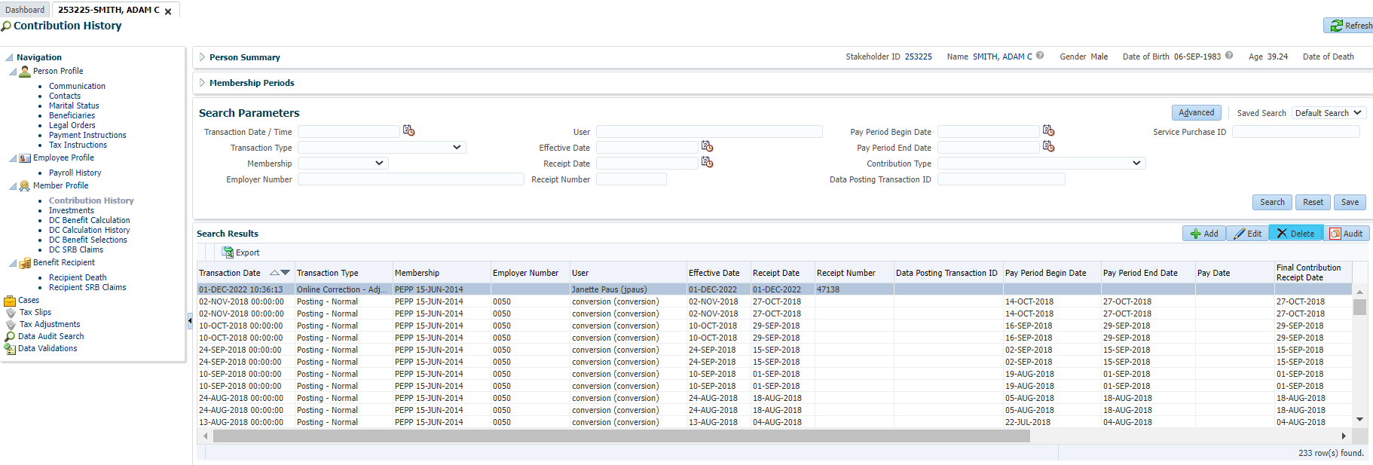

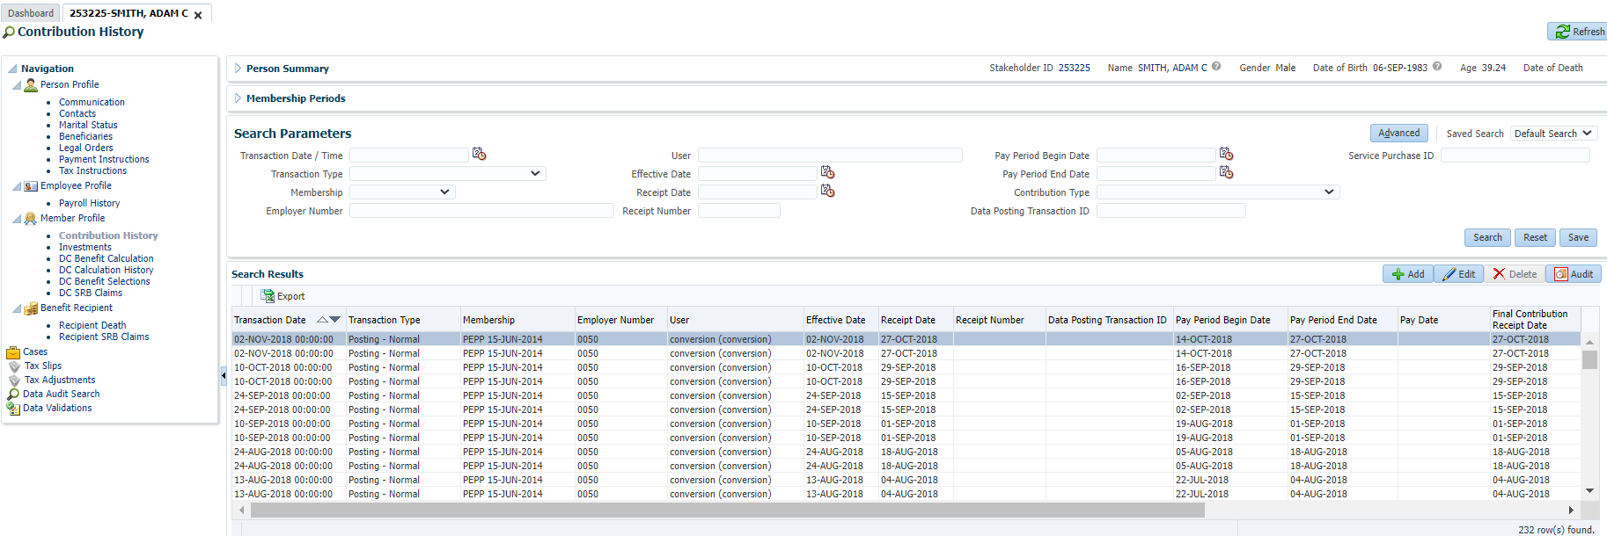

Under Investments/Account activity it shows the reversal, units deposited and units removed due to reversal which is correct.

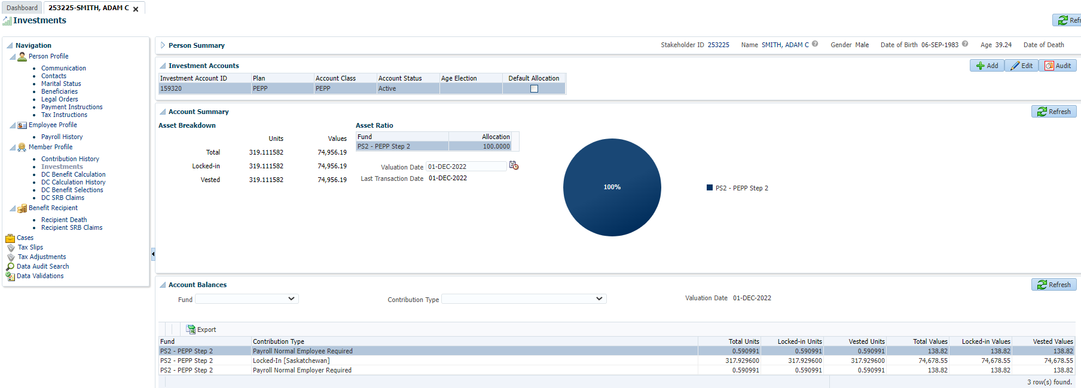

Number of units are back to the amount before the deposit was entered.

Compared number of units to November 30th:

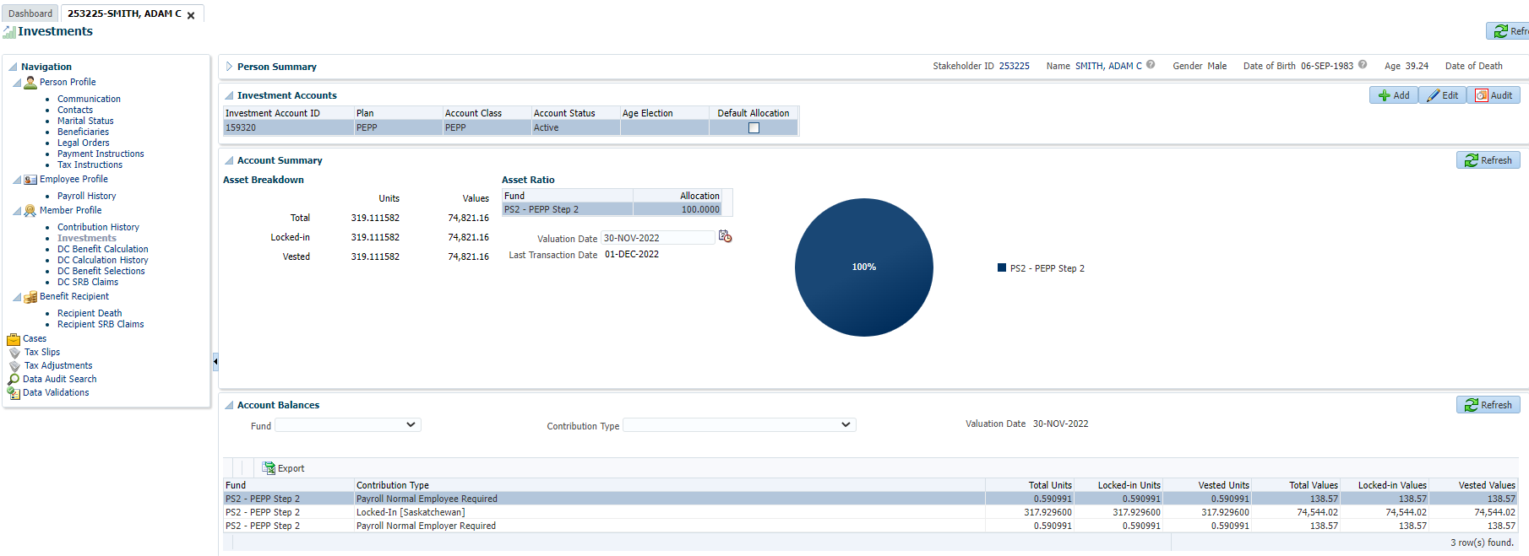

Checked under batches, breakage occurrence, and searched the stakeholder ID.

It shows no breakage.